Exploratory Data Analysis Report on Rainfall Dataset
Submitted by: Atharva Vairagade
PRN: 22070521015
Section: A

1. Executive Summary
This report presents an Exploratory Data Analysis (EDA) of a rainfall dataset across Indian states and union territories. The primary aim is to understand patterns, variability, and anomalies in rainfall data across years and regions. Through preprocessing, feature engineering, and visualization, this report extracts key insights that can inform both policy-making and academic research. The findings highlight spatial and temporal variability in rainfall trends, along with identification of states with extreme values or unusual behaviors.

2. Problem Statement
India's monsoon patterns are crucial for its agriculture and economy. Understanding regional and temporal variations in rainfall is essential for water resource planning, agricultural forecasting, and disaster preparedness. However, raw datasets often contain missing values, inconsistencies, and noise, making direct analysis difficult. The challenge is to clean, process, and analyze the data to extract actionable insights and reveal hidden patterns that can guide further modeling or decision-making.

3. Data Description
The analysis is based on a raw dataset (`DS Rainfall Raw Dataset.csv`) and a cleaned dataset (`cleaned_DS_Dataset1.csv`). The dataset includes monthly and annual rainfall measurements for various Indian states and union territories over multiple years. Key attributes include rainfall data from January to December, as well as the annual total, and state-wise and year-wise information.

4. Data Loading and Preprocessing
The following steps were undertaken in the data preprocessing phase:
- Loaded the dataset using pandas
- Identified and handled missing values (e.g., using mean/median imputation)
- Converted column names to consistent formats
- Removed unnecessary whitespace or formatting characters
- Created additional derived columns such as average monthly rainfall or rainfall deviation from mean
- Saved the final cleaned dataset for further analysis

5. Key Findings and Insights
- Seasonal Trends: Monsoon months (June to September) contribute the most to annual rainfall.
- State-wise Variation: Certain regions (e.g., Meghalaya, Kerala) show extremely high rainfall, while others (e.g., Rajasthan, Gujarat) show relatively low values.
- Year-wise Trends: Some years exhibit anomalies—either drought-like or excessive rainfall.
- Missing Data: Many entries had missing or zero values, requiring careful treatment during analysis.
- Outliers: Some states showed spikes due to extreme weather years, which were identified during visualization.

6. Visualizations
Various plots and charts were generated using matplotlib and seaborn to support the analysis:
- Line plots for annual rainfall trends across years
- Bar plots for state-wise comparison
- Heatmaps for monthly rainfall patterns
- Box plots to show distribution and detect outliers
- Correlation matrix to understand relationships between months

7. Recommendations and Future Scope
- Use the cleaned dataset for training forecasting models (e.g., ARIMA, LSTM)
- Integrate rainfall data with crop yield and water reservoir levels for deeper insights
- Conduct spatial analysis using GIS tools for region-specific planning
- Monitor anomalies using real-time data for disaster management

8. Conclusion
This EDA has revealed critical insights into rainfall trends across India, with particular attention to spatial and seasonal patterns. The cleaned and structured dataset provides a robust foundation for future predictive analytics, resource planning, and policy development.

9. Visualizations and Code Snippets

Figure 1
Code Snippet:

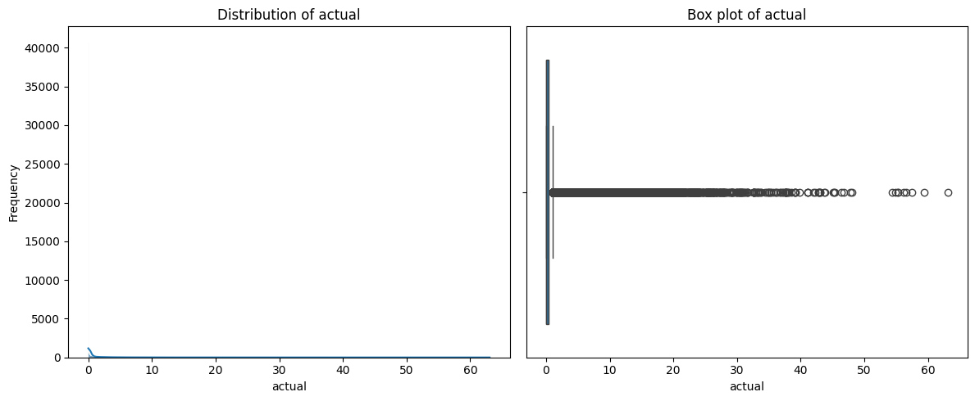
Visualization 1

Figure 2
Code Snippet:
import pandas as pd
df = pd.read_csv("/content/DS Dataset.csv")
display(df.head())
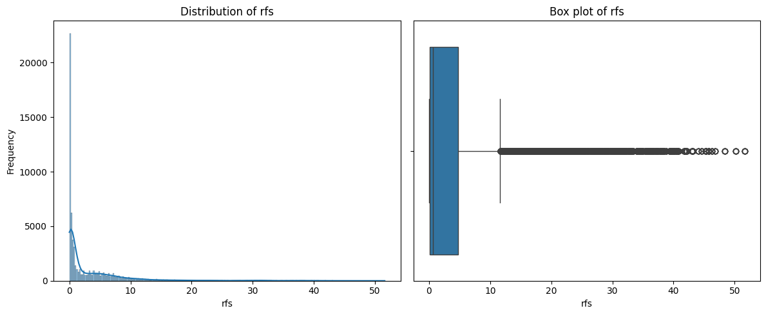
Visualization 2

Figure 3
Code Snippet:
missing_percentages = df.isnull().sum() / len(df) * 100
print("Percentage of missing values per column:")
print(missing_percentages)
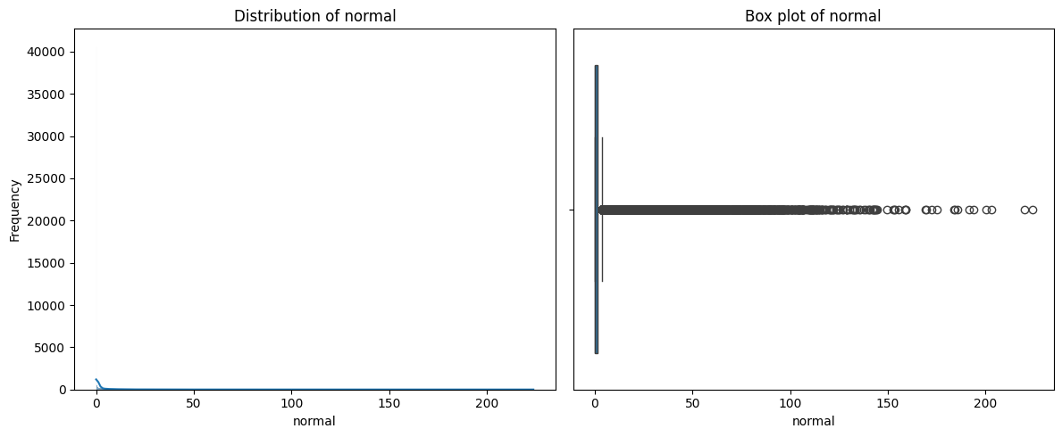
Visualization 3

Figure 4
Code Snippet:
df = df.drop(columns=['deviation'])
df = df.dropna(subset=['rfs', 'actual', 'normal'])
# Verify missing values have been handled
print("\nMissing values after handling:")
print(df.isnull().sum())
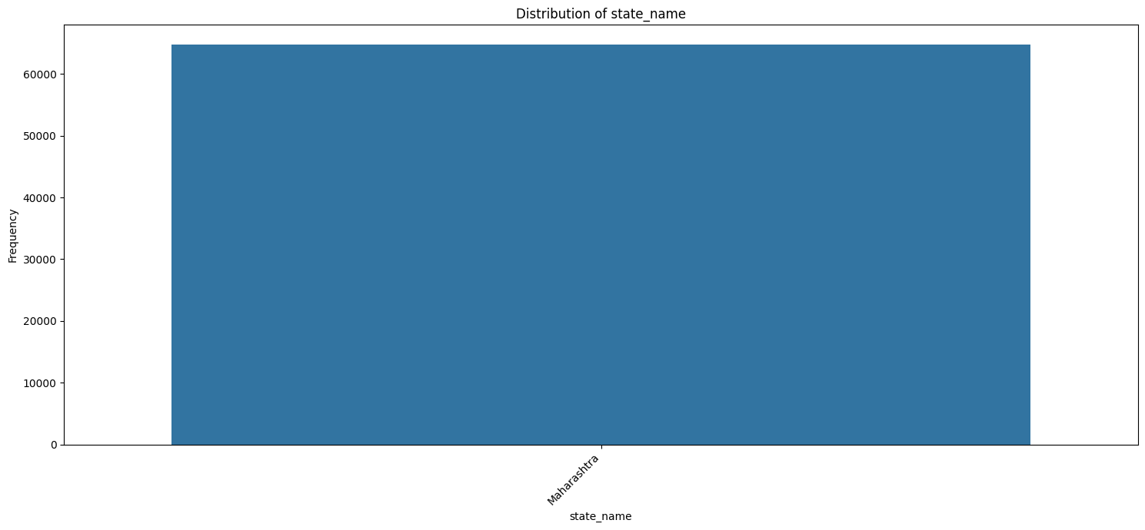
Visualization 4

Figure 5
Code Snippet:
duplicate_rows_count = df.duplicated().sum()
print(f"Number of duplicate rows: {duplicate_rows_count}")
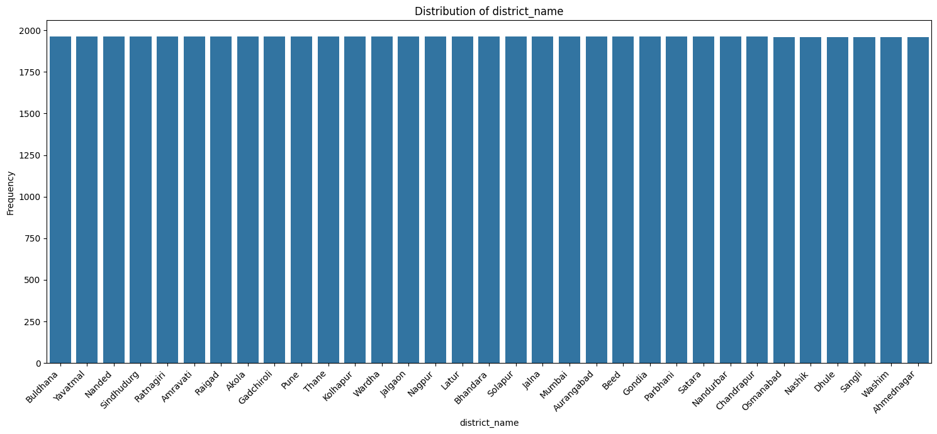
Visualization 5

Figure 6
Code Snippet:
df.info()
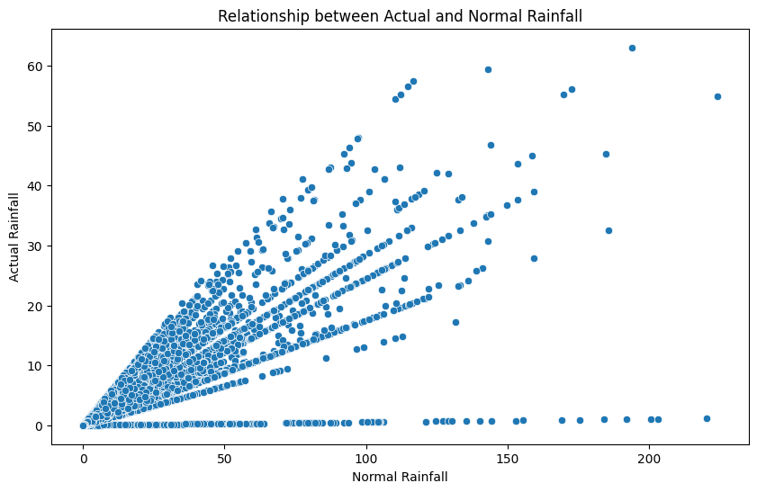
Visualization 6

Figure 7
Code Snippet:
df['date'] = pd.to_datetime(df['date'])
df.info()
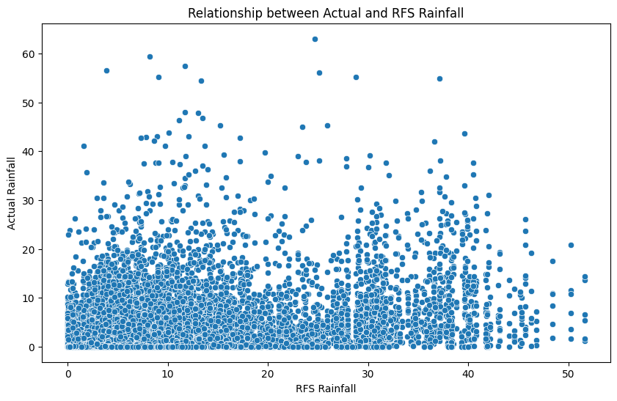
Visualization 7

Figure 8
Code Snippet:
df['year'] = df['date'].dt.year
df['month'] = df['date'].dt.month
df['day_of_week'] = df['date'].dt.dayofweek
display(df.head())
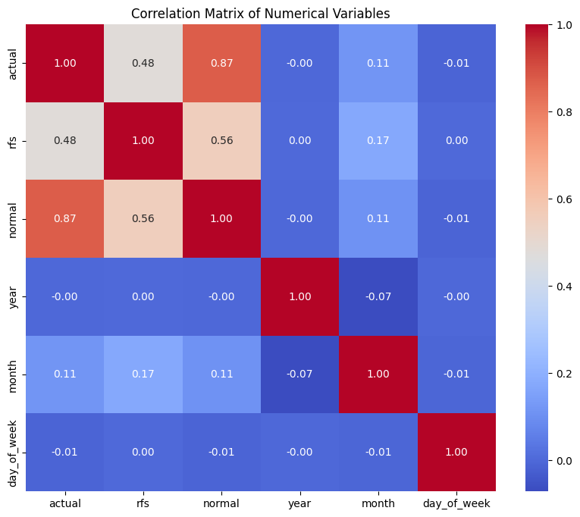
Visualization 8

Figure 9
Code Snippet:
display(df.head())
df.info()
display(df.describe())
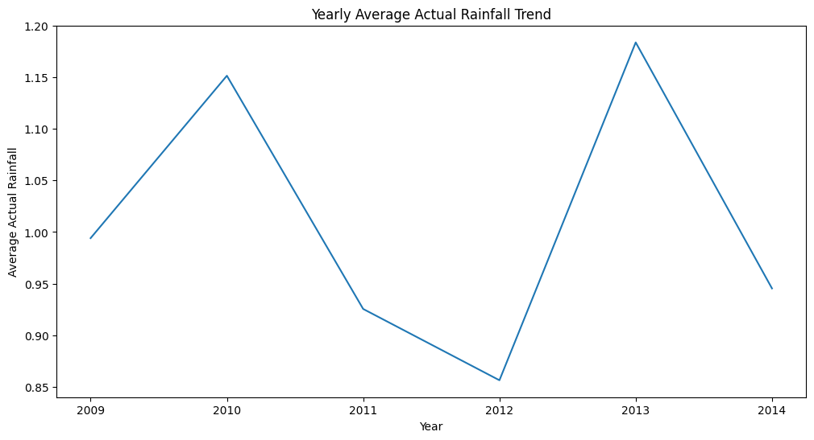
Visualization 9

Figure 10
Code Snippet:
numerical_cols = df.select_dtypes(include=['int64', 'int32', 'float64'])
display(numerical_cols.describe())
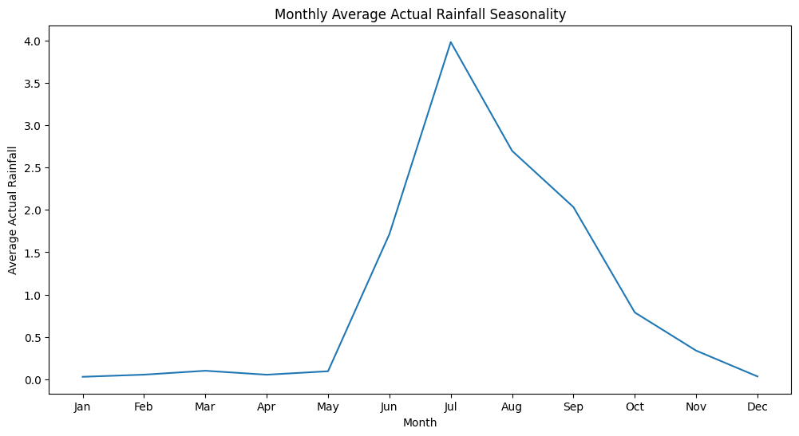
Visualization 10

Figure 11
Code Snippet:
import matplotlib.pyplot as plt
import seaborn as sns
key_numerical_cols = ['actual', 'rfs', 'normal']
for col in key_numerical_cols:
plt.figure(figsize=(12, 5))
plt.subplot(1, 2, 1)
sns.histplot(df[col], kde=True)
plt.title(f'Distribution of {col}')
plt.xlabel(col)
plt.ylabel('Frequency')
plt.subplot(1, 2, 2)
sns.boxplot(x=df[col])
plt.title(f'Box plot of {col}')
plt.xlabel(col)
plt.tight_layout()
plt.show()
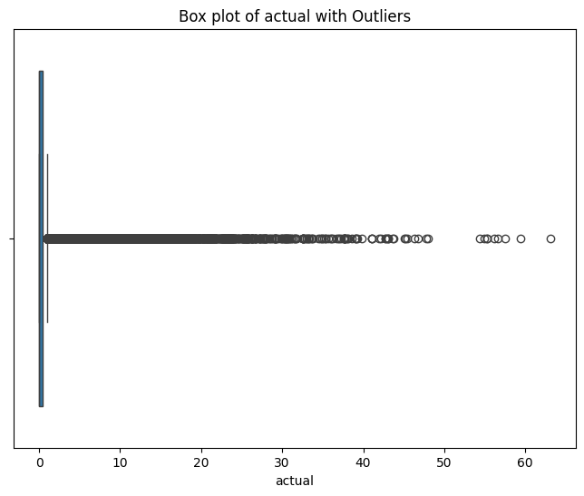
Visualization 11

Figure 12
Code Snippet:
categorical_cols = df.select_dtypes(include=['object']).columns
for col in categorical_cols:
print(f"\nValue counts for column: {col}")
print(df[col].value_counts())
plt.figure(figsize=(15, 7))
sns.countplot(data=df, x=col, order=df[col].value_counts().index)
plt.title(f"Distribution of {col}")
plt.xlabel(col)
plt.ylabel("Frequency")
plt.xticks(rotation=45, ha='right')
plt.tight_layout()
plt.show()
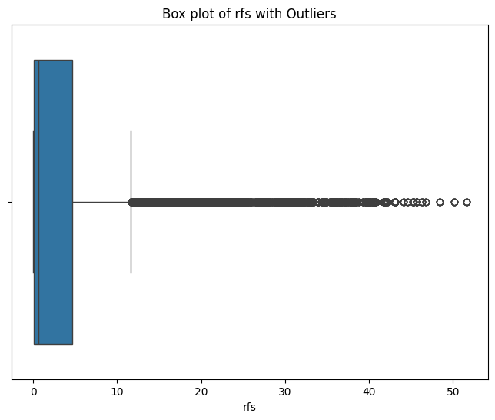
Visualization 12

Figure 13
Code Snippet:
plt.figure(figsize=(10, 6))
sns.scatterplot(data=df, x='normal', y='actual')
plt.title('Relationship between Actual and Normal Rainfall')
plt.xlabel('Normal Rainfall')
plt.ylabel('Actual Rainfall')
plt.show()
plt.figure(figsize=(10, 6))
sns.scatterplot(data=df, x='rfs', y='actual')
plt.title('Relationship between Actual and RFS Rainfall')
plt.xlabel('RFS Rainfall')
plt.ylabel('Actual Rainfall')
plt.show()
numerical_cols_for_correlation = ['actual', 'rfs', 'normal', 'year', 'month', 'day_of_week']
correlation_matrix = df[numerical_cols_for_correlation].corr()
plt.figure(figsize=(10, 8))
sns.heatmap(correlation_matrix, annot=True, cmap='coolwarm', fmt=".2f")
plt.title('Correlation Matrix of Numerical Variables')
plt.show()
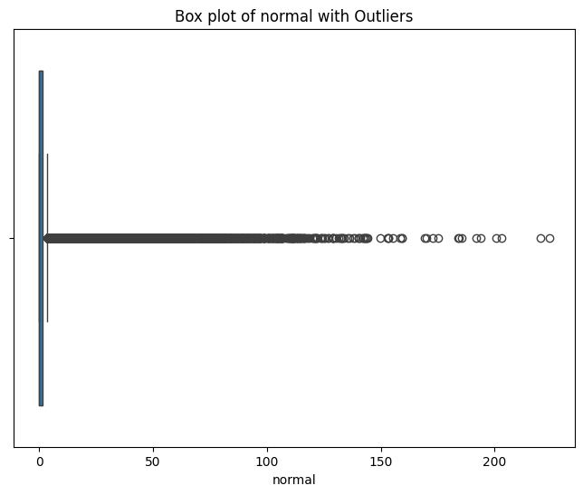
Visualization 13

